Purples glazes
Walter’s Post - Postal Purple #3
Domolite 23%
P-609 14 (.31% Na)
Lithium carb 6
Bone Ash 5
#6 Tile 12
Flint 45
105

+cobalt carb 8
tin oxide 12
pearl ash 1 + 2 = 3a

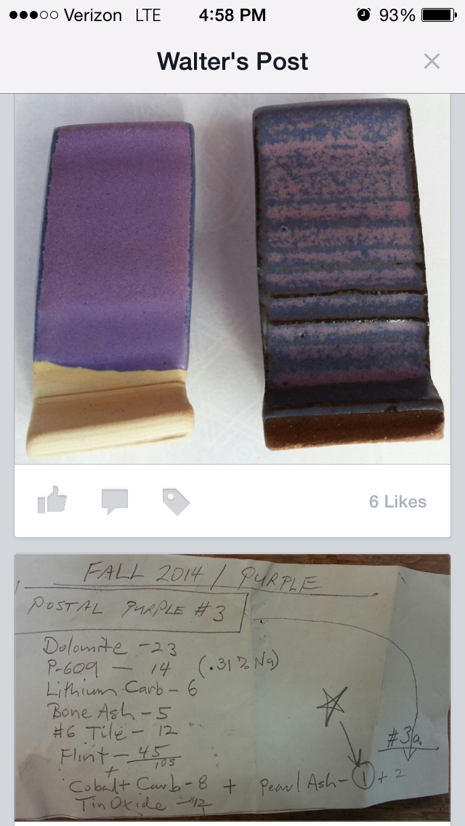

DJ'S GRAPE GLAZE
The Grape glaze with cobalt carbonate came out a perfect purple -- even better than the same recipe using cobalt oxide. Jen said that this was the first time she'd seen a glaze come out actually purple instead of dark blue. She said, "That's DJ's Purple" -- I'll check to make sure its not just a derivative of Jeannie's purple. If it isn't, then I guess its DJ's purple all right! I'm pretty sure the great color is due to the slow cooling at 100 F an hour from 1800 to 1300 degrees. It brings out more red.
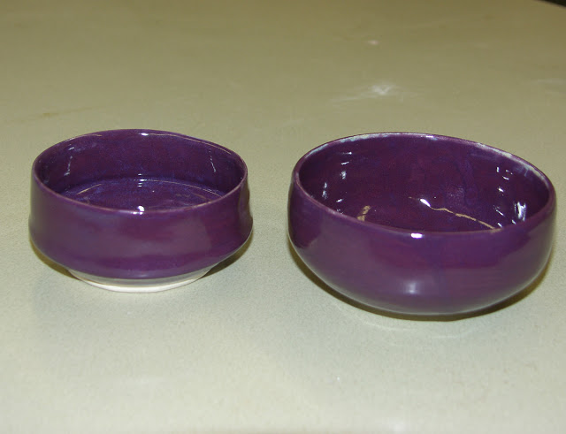

DJ's GRAPE GLAZE WITH COBALT CARBONATE
cone 6 | X1 | X2 | X3 | X5
Neph Sy | 18 | 36 | 54 | 90
Frit 3134 | 14 | 28 | 42 | 70
Whiting | 20 | 40 | 60 | 100
OM4 | 18 | 36 | 54 | 90
Silica | 30 | 60 | 90 | 150
total | 100 | 200 | 300 | 500
oxides
Chrome Ox | 0.2 | 0.4 | 0.6 | 1
Tin Ox | 7.5 | 15 | 22.5 | 37.5
Cobalt Carb | 1 | 2 | 3 | 5
RIO | 0.5 | 1 | 1.5 | 2.5

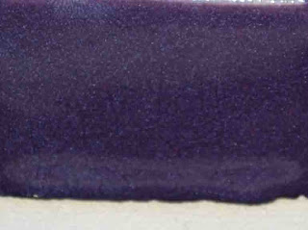
54

54 | Jeannie's Purple Semigloss C/6
 | Neph Syenite | 0.18
 | Frit 3134 | 0.14
 | Whiting | 0.2
 | OM#4 Ball Clay | 0.18
 | Silica | 0.3
 | Chromium Oxide | 0.002
 | Tin Oxide | 0.038
 | Cobalt Carbonate | 0.006
-----------------

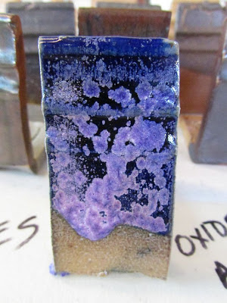

Hey kids, got this great tile as a accident in a workshop firing a light soda/salt cone 10 firing. But need some verification that it works more than once.

If anyone could try it and see I would appreciate it!

Haynes Base with 5% cobalt carbonate cone 10 soda

Nepheline Syenite: 45.00 Grams
Silica: 30.00 Grams
Whiting: 8.00 Grams
Dolomite: 10.00 Grams
Talc: 7.00 Grams
Total: 100.00 Grams
Add : 5% cobalt carbonate

Fire in light salt or soda

